AIM:
To create and allocate a Virtual Hard Disk (VHD) for a virtual machine using VMware Workstation.

PROCEDURE:
- Open VMware Workstation on the host device.
- Select the Virtual Machine in which the new hard disk is to be created.
- Go to VM → Settings → Hardware tab.
- Click Add → Hard Disk → Next.
- Choose the disk type (SCSI / SATA / NVMe) and continue.
- Select Create a new virtual disk and click Next.
    - Specify the disk size (e.g., 40 GB) and choose whether to: Store as a single file, or
    - Split into multiple files.

  - 7.Assign the file location and disk name, then finish the setup.
  - 8.Start the Virtual Machine and open the Disk Management utility inside the OS.
  - 9.Initialize the new disk, create a partition, and format it (NTFS/EXT4).
  - 10.Verify that the allocated virtual disk is now available for use.

  - OUTPUT

  - 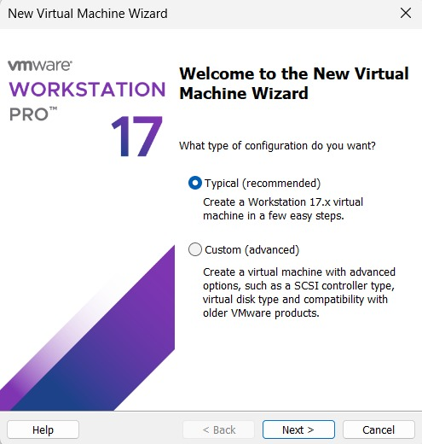
.
RESULT:
A Virtual Hard Disk (VHD) was successfully created and storage was allocated to the virtual machine in VMware Workstation

